**CLOUD COMPUTING  
PRACTICAL 8:AMAZON SAGEMAKER**

**1)Creating IAM ROLE and assigning sagemaker permission**

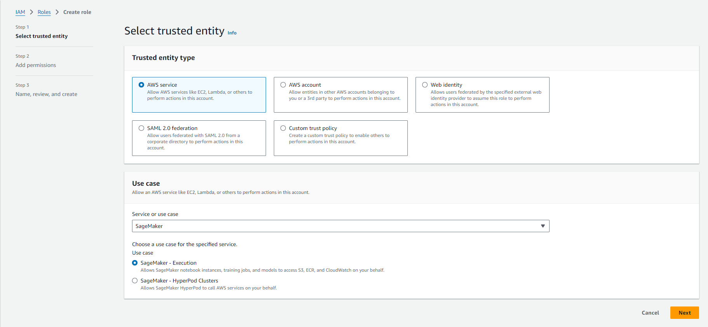

**IAM Role is created.**

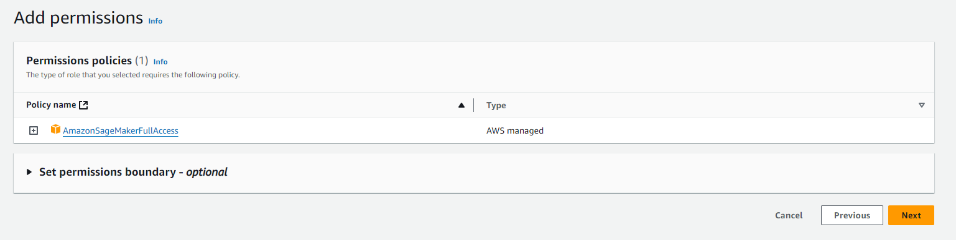

**2) creating s3 bucket named mygroup2**

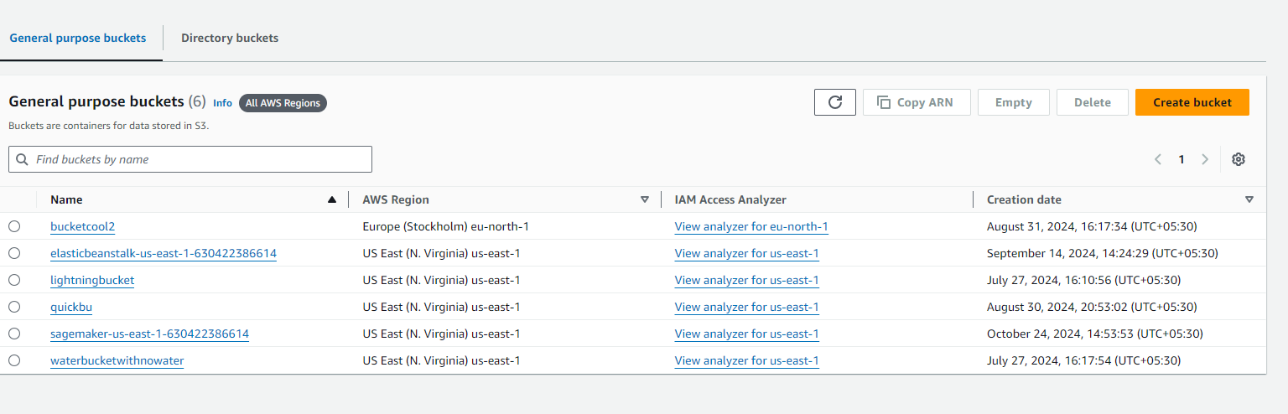

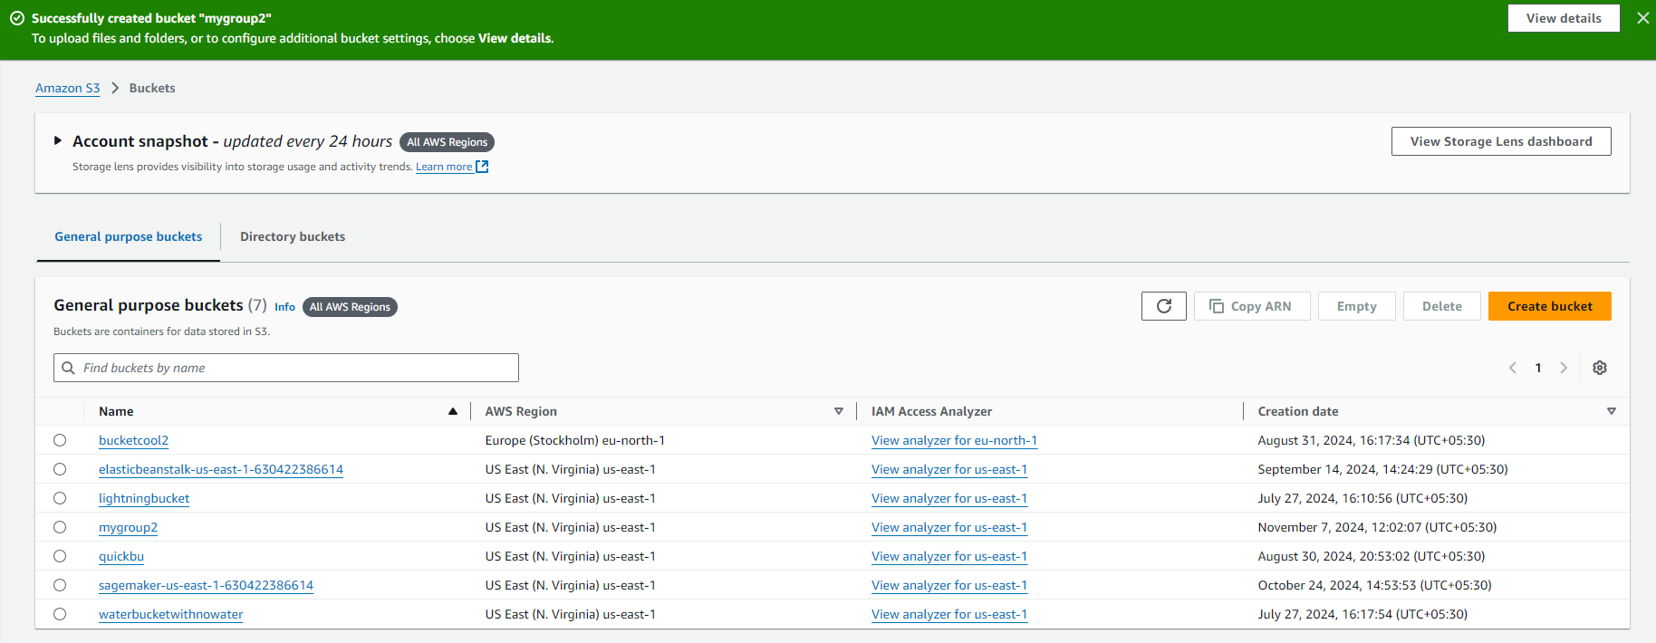

**3)open Amazon SageMaker console**

**Select Notebook instances and click create notebook instances**

**Here we will assign the IAM role created earlier i.e fraud_detection**

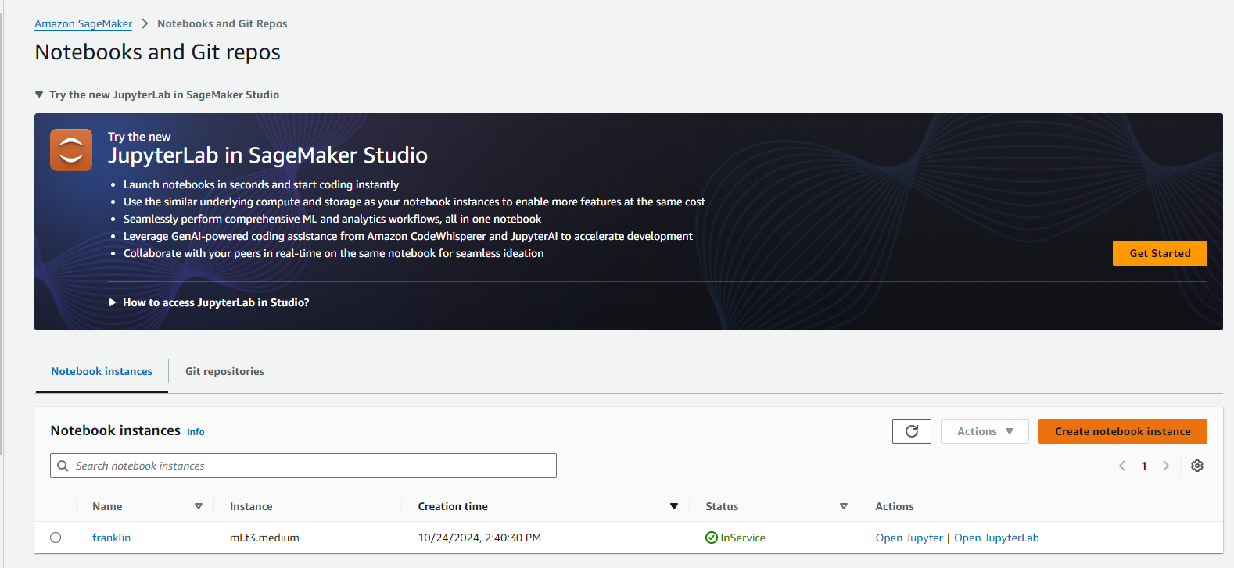

**4) CREATE A JUPYTER NOTEBOOK**

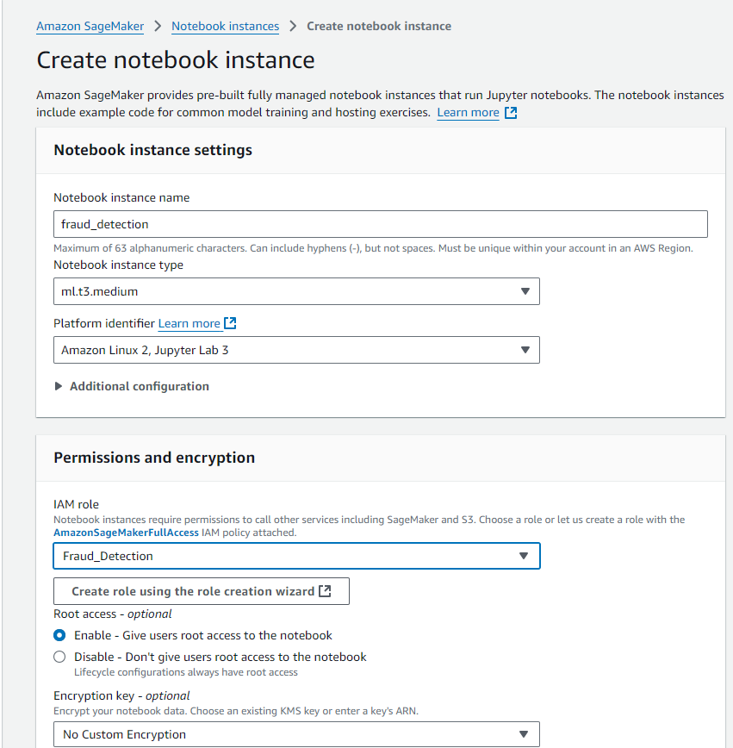

**Notebook is created**

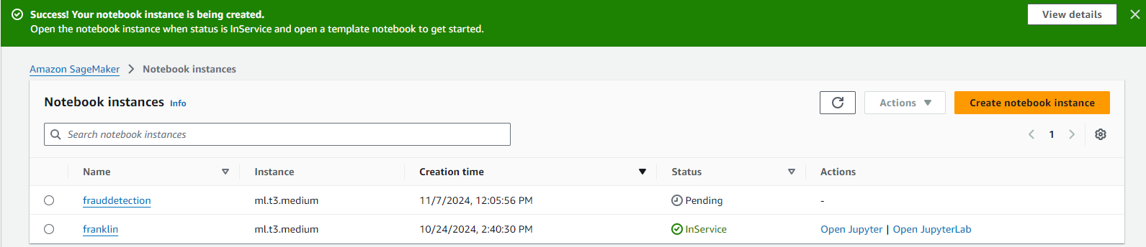

1. Open Jupyter or JupyterLab according to the interface needed.
2. Go to File menu->Choose New-> Notebook.
3. Select Kernel as ‘conda_python3’

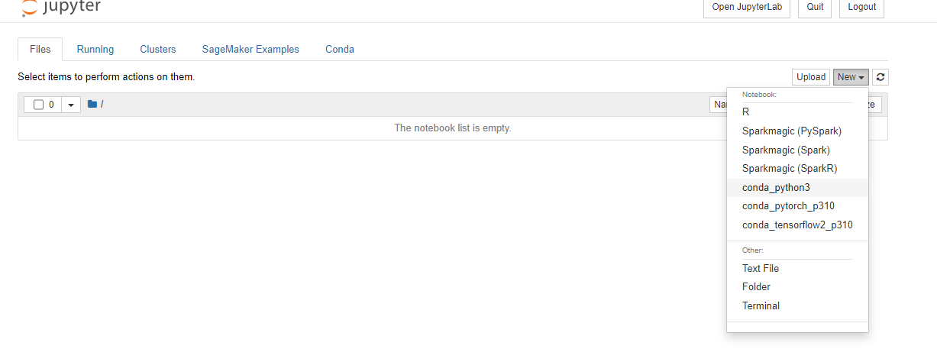

**Deploying the model (Here it is stored in s3 bucket that we had created)**

